CODE APHA ML INTERNSHIP
Stages of System Development: Character Recognition (MNIST)
- Choosing and Obtaining the Dataset
For Task 4 (Character Recognition), we make use of a Neural Network / Convolutional Neural Network (CNN) approach or dense Neural Network architecture using Keras / TensorFlow.
- Dataset Selection: We utilize the MNIST Handwritten Digit Dataset, which consists of 70,000 grayscale images of digits (0 through 9) formatted as 28x28 pixel grids.
- Obtaining Data: The dataset is imported directly via keras.datasets.mnist or downloaded as CSV/Numpy array files into the project directory.

- 2. Understanding and Normalizing the Input Data
The raw dataset consists of digit images where each pixel value ranges from 0 to 255 (0 representing black, 255 representing white, and values in between representing shades of gray).
- Features (X): The pixel intensity matrices representing image samples.
- Target (y): Categorical ground-truth labels indicating digits from 0 to 9.
- Reshaping: Images are reshaped into (-1, 28, 28, 1) or flattened into a 1D vector of length 784 (28 * 28), depending on the layer architecture.
- Data Normalization: Pixel values are divided by 255.0 to rescale feature values to a floating-point range between 0.0 and 1.0. This normalization helps gradient descent converge faster during model training.

- Data Separation and Preprocessing
Before feeding data into the neural network, we split and preprocess the dataset:
- Train / Test Split: Data is split into Training Set (typically 80% or 60,000 samples) and Testing Set (typically 20% or 10,000 samples).
- Label Encoding: Labels (0–9) are converted to one-hot encoded vectors or handled via Sparse Categorical Crossentropy to align with the final activation layer.

- 4. Neural Network Architecture & Training
We construct a multi-layer neural network architecture consisting of:
- Input / Flatten Layer: Converts the 28x28 image grid into a 1D line of 784 pixels.
- Hidden Layer(s): Dense layers with Activation Functions (such as ReLU) where deep feature extraction and learning occur.
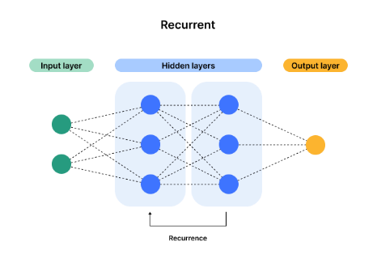
- Output Layer: A Dense layer with 10 nodes (representing digits 0–9) paired with a Softmax activation function to output class probabilities for each digit.

- Model Evaluation and Performance Tuning
Initial Evaluation: Model accuracy and loss are evaluated on the test set.
Hyperparameter Tuning: Adjustments to batch size, epochs, number of hidden layer units, and learning rate are performed to maximize validation accuracy.

- Saving, Exporting, and Deployment
- Saving Model: The trained model is exported as a .keras or .h5 file using Keras saving utilities to preserve architecture, weights, and optimizer configuration.
- Deployment: Integrated with a backend service (e.g., FastAPI) to connect with a web interface (HTML/JS or React) for real-time digit prediction.

